HP 6632A power supplies
POSTED BY KALLE HYVÖNEN POSTED ON JUL - 19 - 2012

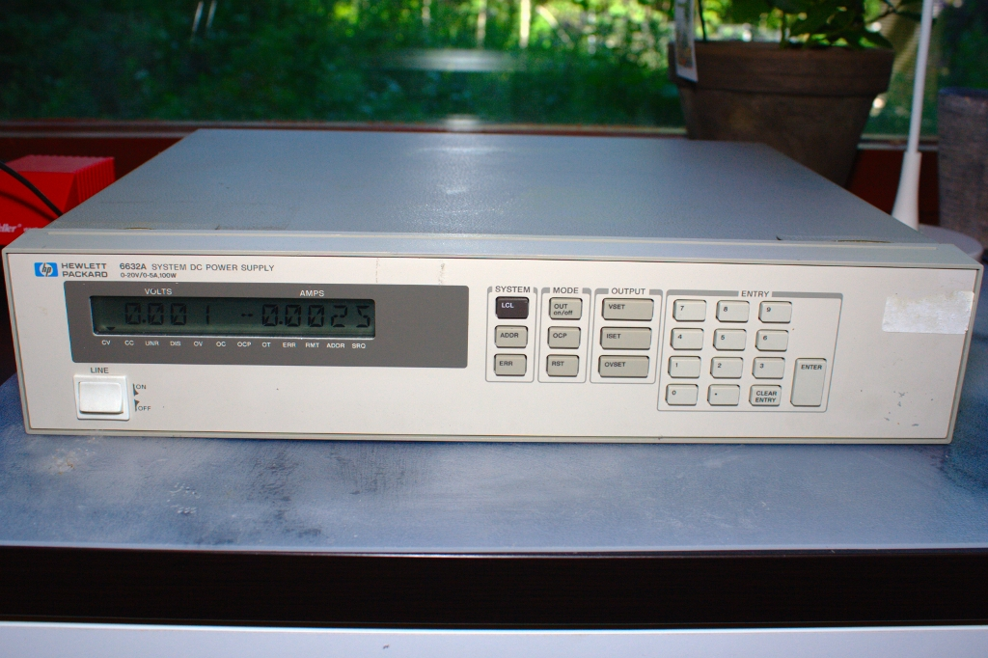
HP 6632A front side

Maybe the best feature of these power supplies is that they can source as well as sink current - which means you can use it as a programmable load. So with a pair of these power supplies you can make an automated SMPS characterization setup. One of the 6632As would feed the device under test and measure the current and voltage, and the other one would sink the output from the SMPS and measure the current and voltage. From this information you can make a supply voltage vs. efficiency plot of the SMPS.

One bad feature of these power supplies is that they are very slow in changing from CV to CC mode. It takes over 70ms for them to react, so for 70ms they stay in CV mode, which could mean tens of times more current for 70ms than you have specified!! The overcurrent protection feature is equally slow, as it just disables the output when the CC-mode kicks in. You can see the behaviour in these waveforms:
(voltage set to 5V, current set to 100mA, output gets shorted with 10 Ohm)

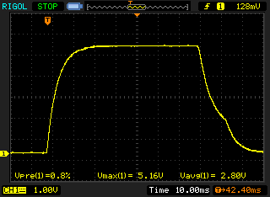
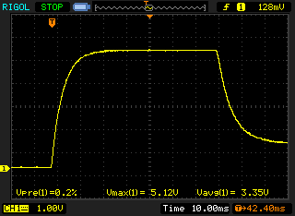
normal mode normal mode, OCP enabled

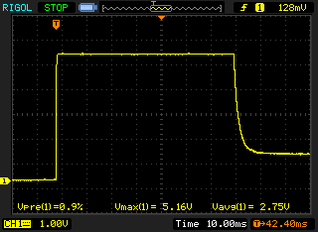
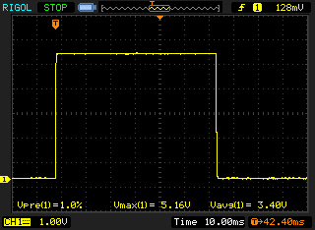

fast mode fast mode, OCP enabled

HP/Agilent has said, that this is normal behaviour for PSUs designed mainly as constant-voltage supplies. There’s a workaround to this feature: you can short out the output, turn the output on, let the CC-mode kick in and then remove the short with the intended load (like say an LED). Still sucks though.

